R. Reports Menu: 6. Animal History File Report

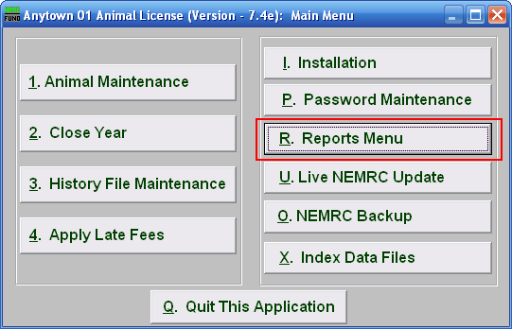
Click on “R. Reports Menu” from the Main Menu and the following window will appear:

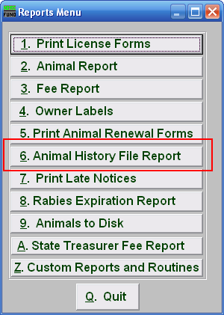
Click on “6. Animal History File Report” from the Reports Menu and the following window will appear:

Animal History File Report

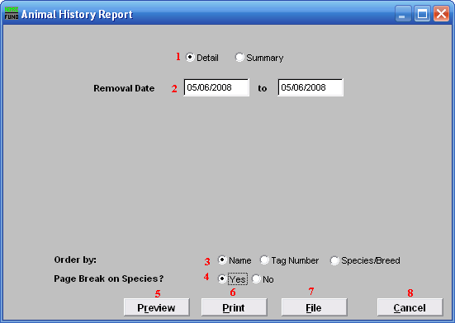
- Detail OR Summary: Choose whether this report will show all details or be a summary.

- Removal Date: Enter the date range that you wish this report to show Animals removed.

- Order by: Select whether this report will print in order of Owner Name, Tag Number, or Species/Breed.

- Page Break on Species?: Select if this report will start a new page for each species.

- Preview: Click this button to preview. Refer to GENERAL PREVIEW for more information.

- Print: Click this button to print. Refer to GENERAL PRINTING for more information.

- File: Click this button to save on this computer. Refer to GENERAL FILE for more information.

- Cancel: Click “Cancel” to cancel and return to the previous screen.

